SPARK OS
A Project Based Learning Report Submitted in partial fulfilment of the requirements for the award of the degree

of

Bachelor of Technology
in The Department of CSE
25CS2104E - OPERATING SYSTEMS AND SYSTEMS PROGRAMMING

Submitted by
2510030251 – ANANYA
2510030081 – UDAY KIRAN.K
2510030061 – HARSHA
2510030205 - CHARAN

Under the guidance of
Mr. Pavan Pagadala



Department of Electronics and Communication Engineering
Koneru Lakshmaiah Education Foundation, Aziz Nagar
Aziz Nagar – 500075
OCT - 2026.
Abstract

Operating System concepts such as process management, inter-process communication, memory management, file management, system calls, and synchronization are often introduced through theoretical explanations and conventional command-line examples. This can make it difficult for beginners to connect the underlying concepts with their actual execution and behavior. Spark OS is developed as an educational mini-operating-system and interactive learning environment designed to bridge this gap.
The project provides a command-based interface through which students can explore major Operating System concepts using short theoretical explanations, visual representations, practical demonstrations, and observable results. The learning methodology follows the sequence Theory → Diagram → Practical Demo → Result, allowing students to move from conceptual understanding to execution-based observation.
The implemented environment demonstrates process tables, process states, Round Robin scheduling, process creation, pipes, FIFO and signals, memory layout and dynamic allocation, file I/O, file descriptors and inode concepts, POSIX threads, mutexes, semaphores, and system-call concepts. The project also distinguishes between the bootable educational mini-kernel and the Ubuntu-based practical demonstration environment used to demonstrate OS and POSIX concepts.
The final system is modular and command-based, allowing students to directly access individual concepts without navigating complex interfaces. The project aims to provide a beginner-friendly approach to understanding Operating Systems by combining theory with diagrams and observable practical demonstrations.

List of Figures

Figure 1. Spark OS Interactive Learning Methodology
Figure 2. Spark OS Main Command-Based Interface
Figure 3. Spark OS System Architecture
Figure 4. Process State Transition Diagram
Figure 5. Process Table Demonstration
Figure 6. Round Robin Scheduling Representation
Figure 7. Process Creation Demonstration
Figure 8. Pipe Communication Diagram and Demonstration
Figure 9. FIFO Communication Demonstration
Figure 10. Signal Communication and Signal Handler Demonstration
Figure 11. Process Memory Layout
Figure 12. Dynamic Memory Allocation Demonstration
Figure 13. File I/O Demonstration
Figure 14. File Descriptor Demonstration
Figure 15. Inode Concept Demonstration
Figure 16. Thread Demonstration
Figure 17. Mutex Synchronization Demonstration
Figure 18. Semaphore Demonstration
Figure 19. System Call Demonstration
Figure 20. Final Spark OS Integrated Execution

List of Tables

Table 1. Spark OS Learning Module
Table 2. Spark OS Command Mapping
Table 3. Process Management Demonstrations
Table 4. IPC Demonstrations
Table 5. Memory Management Demonstrations
Table 6. File Management Demonstrations
Table 7. Thread and Synchronization Demonstrations
Table 8. Overall Demonstration Methodology

Table of Contents
Table of Contents 5
1. INTRODUCTION 7
1.1 Background 7
1.2 Problem Statement 7
1.3 Proposed Solution 8
1.4 Objectives 9
1.5 Scope of the Project 10
1.6 Novelty of the Project 11
2. METHODOLOGY 12
2.1 Overall Methodology 12
2.2 System Architecture 13
2.3 Command-Based Learning Environment 14
2.4 Process Management Module 15
2.5 Inter-Process Communication Module 22
2.5.1 Pipe 23
2.5.2 FIFO 23
2.5.3 Signals 24
2.6 Memory Management Module 25
2.6.1 Dynamic Memory Allocation 26
2.7 File Management Module 27
2.7.1 File I/O 28
2.7.2 File Descriptors 28
2.7.3 Inode Concept 29
2.8 Threads and Synchronization Module 30
2.8.1 Threads 30
2.8.2 Mutex 31
2.8.3 Semaphore 32
2.9 System Call Module 33
3. EXPERIMENTS 35
3.1 Process Management Experiments 35
3.2 IPC Experiments 36
3.3 Memory Experiments 37
3.4 File Management Experiments 37
3.5 Thread and Synchronization Experiments 38
3.6 System Call Experiment 39
4. RESULTS 40
4.1 Overall System Result 40
4.2 Process Management Result 41
4.3 IPC Result 42
4.4 Memory Management Result 42
4.5 File Management Result 43
4.6 Thread and Synchronization Result 44
4.7 System Call Result 45
4.8 Integrated Final Demonstration 46
4.9 Summary of Implemented Modules 46
5. CONCLUSION AND FUTURE WORK 48
5.1 Conclusion 48
5.2 Advantages 48
5.3 Limitations 49
5.4 Future Scope 49
6. REFERENCES 51

1. INTRODUCTION

1.1 Background
An Operating System is a fundamental component of a computer system that provides an interface between users, application programs, and computer hardware. It manages system resources and provides services required for programs to execute. Important Operating System concepts include processes, process scheduling, inter-process communication, memory management, file systems, system calls, threads, and synchronization.
Understanding these concepts is important for students because they explain how computer programs execute, communicate, access resources, and share system resources. However, many Operating System concepts are abstract and involve internal activities that are not directly visible to a beginner. For example, a process changes between different states during its lifetime, a scheduler allocates CPU time among processes, processes communicate through IPC mechanisms, and threads require synchronization when accessing shared resources.
Traditional learning approaches often introduce these topics through definitions, diagrams, algorithms, and theoretical examples. Although these methods are useful, students may find it difficult to connect the theoretical explanation with the actual behavior of a program during execution. A student may know the definition of a process state or a semaphore without being able to visualize what happens when the concept is actually executed.
This creates a gap between conceptual knowledge and observable execution.
Spark OS was developed to address this learning gap by providing an interactive educational environment for Operating System concepts. Instead of treating each concept only as a theoretical topic, Spark OS provides a sequence in which the learner first understands the concept, visualizes its behavior, executes a practical demonstration, and observes the resulting output.

1.2 Problem Statement
Operating System concepts are often difficult for beginners because many of the important activities performed by an operating system occur internally and are not directly visible to the learner.
Students may understand concepts such as process states, scheduling, pipes, memory allocation, file descriptors, threads, mutexes, and system calls individually, but connecting the theoretical definition with actual program behavior can be difficult.
Therefore, there is a need for a simple and interactive learning environment that connects:
Theory → Visualization → Practical Execution → Observable Result
Spark OS addresses this requirement through a command-based educational environment.

1.3 Proposed Solution
Spark OS is an educational mini-OS and command-based Operating System concepts learning environment.
The system provides separate modules for major Operating System concepts. Each module provides short theoretical information, diagrammatic representations and practical demonstrations.
The learner interacts with the system through simple commands. This avoids complex navigation and allows the student to directly select the concept that they want to study.
The project follows the learning sequence:
CONCEPT
↓
THEORY
↓
DIAGRAM
↓
COMMAND
↓
PRACTICAL DEMONSTRATION
↓
RESULT
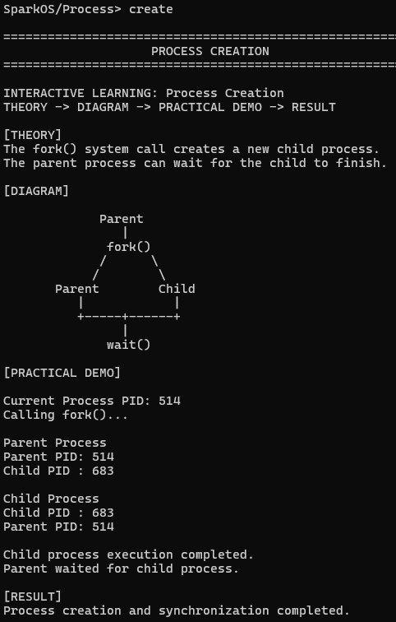

1.4 Objectives
The major objectives of Spark OS are:
- To provide a beginner-friendly environment for understanding Operating System concepts.
- To demonstrate important Operating System concepts through practical execution.
- To provide diagrammatic representations for concepts that are difficult to visualize.
- To provide a command-based interface for accessing different learning modules.
- To demonstrate process management and CPU scheduling concepts.
- To demonstrate inter-process communication mechanisms.
- To demonstrate basic memory management concepts.
- To demonstrate file I/O, file descriptors and inode concepts.
- To demonstrate threads and synchronization mechanisms.
- To demonstrate the conceptual flow of system calls.
- To combine theory, visualization and practical execution within one learning environment.

1.5 Scope of the Project
The scope of Spark OS focuses on educational demonstration of fundamental Operating System concepts.
The implemented learning environment covers:
- Process Management
- Process States
- Round Robin Scheduling
- Process Creation
- Inter-Process Communication
- Pipes
- FIFO
- Signals
- Memory Layout
- Dynamic Memory Allocation
- File I/O
- File Descriptors
- Inode Concept
- Threads
- Mutex Synchronization
- Semaphores
- System Calls
The system is intended primarily as an educational tool and demonstration environment. It is not intended to replace a production operating system or provide complete implementations of all operating-system subsystems.

1.6 Novelty of the Project
The main novelty of Spark OS is its interactive educational methodology.
Instead of providing only theoretical explanations, the system connects four stages:
Theory → Diagram → Practical Demonstration → Result
The student first receives a short explanation of the concept. A diagram is then used to visualize the concept. The learner executes a command corresponding to the concept and finally observes the practical result.
This approach provides a direct connection between what the student learns and what the student observes.
The project therefore combines:
- Interactive learning
- Visual representation
- Practical execution
- Command-based interaction
- Modular learning
The novelty is not that Spark OS creates a completely new operating-system algorithm. The novelty lies in how fundamental OS concepts are presented together as an interactive educational experience.

2. METHODOLOGY

2.1 Overall Methodology
Spark OS follows a structured learning methodology designed to move the learner from theoretical understanding to practical observation.
The methodology consists of four major stages:
- Stage 1 — Theory
The concept is introduced using a short and simple explanation.
- Stage 2 — Diagram
A diagrammatic representation is provided to help the learner visualize the concept.
- Stage 3 — Practical Demonstration
The learner executes a command corresponding to the selected concept.
- Stage 4 — Result
The system displays the practical output so that the learner can observe the behavior.
The overall methodology is:
THEORY
↓
DIAGRAM
↓
PRACTICAL DEMONSTRATION
↓
RESULT
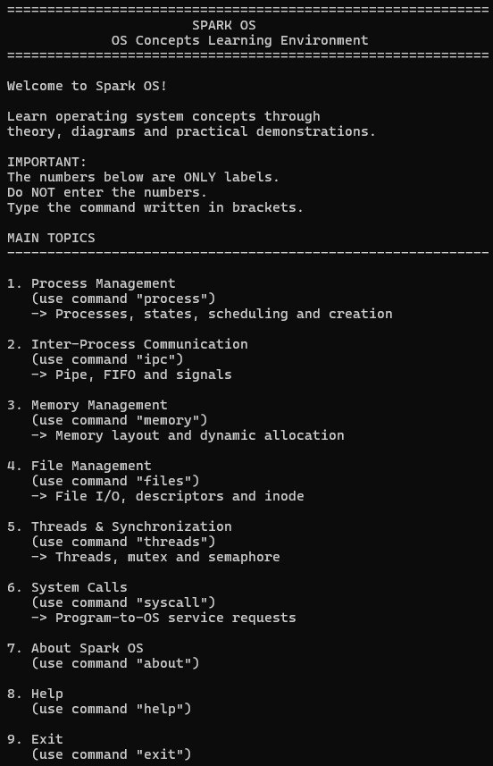

2.2 System Architecture
Spark OS uses a command-based interface as the primary interaction layer.
The user enters a command, and the corresponding module is executed.
The general architecture can be represented as:
USER
|
v
COMMAND-BASED INTERFACE
|
v
SPARK OS
|
+-----------+-----------+
| | |
PROCESS IPC MEMORY
| | |
+-----------+-----------+
|
+----------+----------+
| |
FILES THREADS & SYNCHRONIZATION
|
v
SYSTEM CALLS

The project also contains complementary implementation environments. The project initially included a bootable mini-kernel implementation, while the final practical learning environment demonstrates OS and POSIX concepts within Ubuntu. The Ubuntu environment provides practical access to facilities such as processes, pipes, signals, memory allocation, files, threads and synchronization.

2.3 Command-Based Learning Environment
The interface is designed to use commands rather than requiring the learner to navigate through numerical menus.
The user can enter commands such as:
process
ipc
memory
files
threads
syscall
about
help
exit
Inside individual modules, specific commands can be used to access demonstrations.
For example, the Process Management module provides commands such as:
table
states
schedule
create
back
This design allows the learner to directly associate a command with a concept.

2.4 Process Management Module
The Process Management module demonstrates the representation and lifecycle of processes.
The module contains demonstrations for:
- Process Table
- Process States
- Round Robin Scheduler
- Process Creation
- Process Table
A process table contains information associated with processes, such as process identification and process state.
Command:
Table
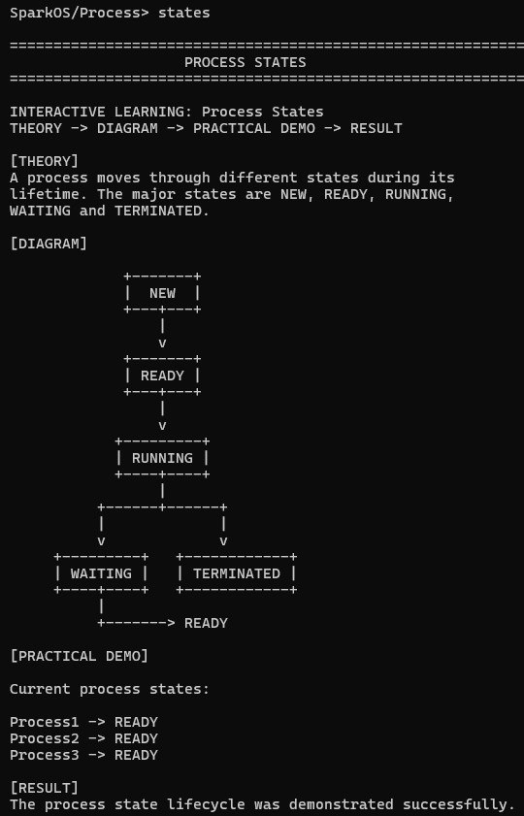
- Process States
The process state demonstration represents the lifecycle of a process.
NEW
|
v
READY
|
v
RUNNING
/ \
/ \
v v
WAITING TERMINATED
|
v
READY
- Round Robin Scheduling
Round Robin scheduling demonstrates how CPU time can be shared among processes by giving each process a fixed time quantum.
The project uses a time quantum of 2 in its demonstration.
Example execution order:
P1 → P2 → P3 → P1 → P2 → P3 → P1
Command:
Schedule
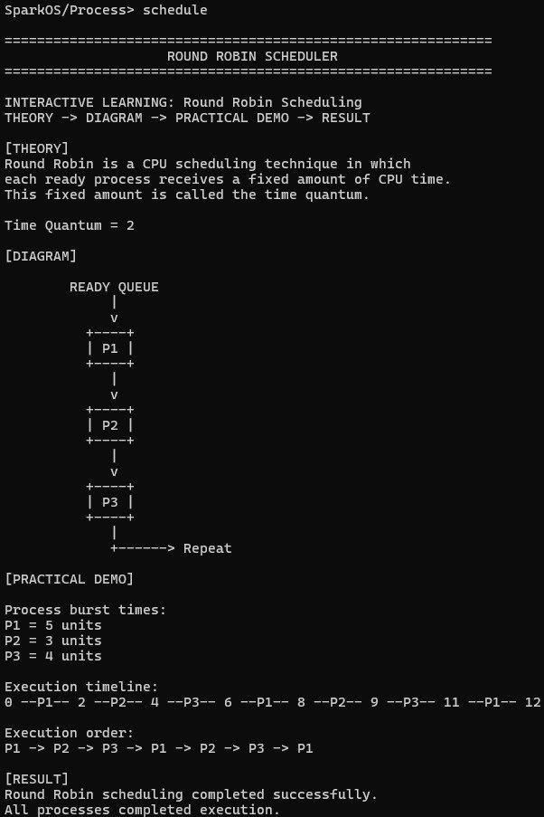
- Process Creation
The process creation demonstration uses the process creation mechanism available in the Ubuntu environment.
Conceptually:
PARENT
|
fork()
|
+-----+-----+
| |
PARENT CHILD
Command:
create

2.5 Inter-Process Communication Module
Inter-Process Communication allows processes to exchange information or coordinate their activities.
Spark OS demonstrates:
- Anonymous Pipe
- FIFO
- Signals

2.5.1 Pipe
A pipe provides a communication channel between processes.
The basic communication flow can be represented as:
PARENT PROCESS
|
| Message
v
PIPE
|
v
CHILD PROCESS
Command:
pipe
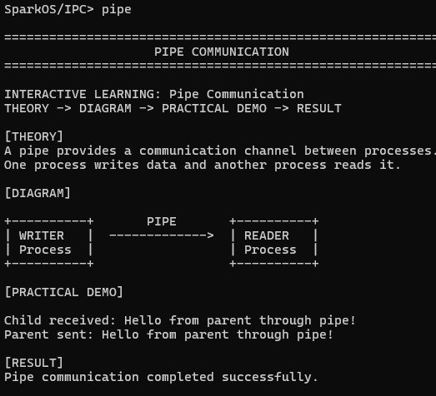

2.5.2 FIFO
A FIFO provide named inter-process communication.
The demonstration helps students understand that processes can communicate through a named communication mechanism.
Command:
fifo
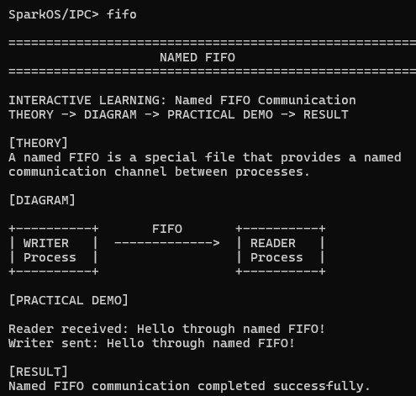

2.5.3 Signals
Signals provide a mechanism for asynchronous notification between processes.
The demonstration follows:
PROCESS
|
| Signal
v
SIGNAL HANDLER
|
v
RESPONSE
Command:
signal
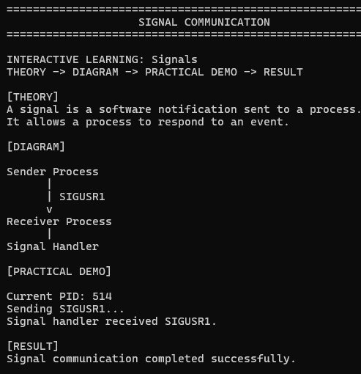

2.6 Memory Management Module
Memory management is demonstrated through process address-space representation and dynamic memory allocation.
A simplified process address-space representation is:
HIGH ADDRESS
+----------------+
| STACK |
+----------------+
| ... |
+----------------+
| HEAP |
+----------------+
| BSS |
+----------------+
| DATA |
+----------------+
| TEXT |
+----------------+
LOW ADDRESS
The demonstration explains the role of the major regions of a process address space.
Command:
memory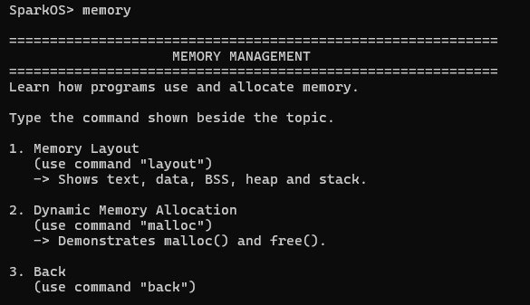

2.6.1 Dynamic Memory Allocation
Dynamic memory allocation is demonstrated using malloc() and free().
The practical flow is:
malloc()
|
v
HEAP MEMORY
|
v
STORE DATA
|
v
free()
Command:
malloc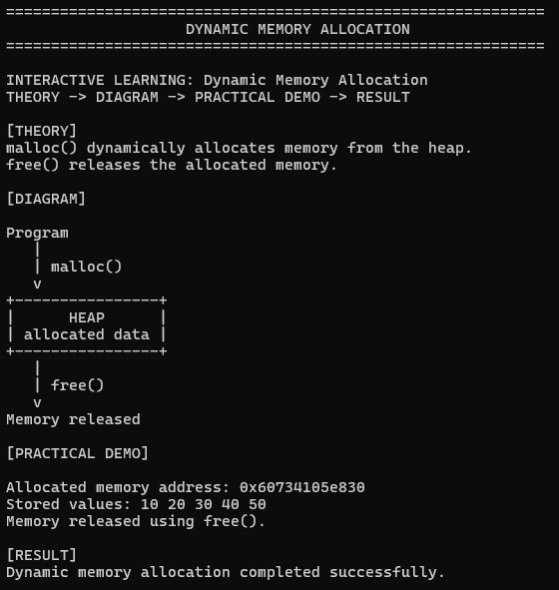

2.7 File Management Module
The File Management module demonstrates basic file-related concepts.
The module contains:
- File I/O
- File Descriptors
- Inode Concept

2.7.1 File I/O
The demonstration creates and accesses a file to show basic file input/output.
Command:
files
The 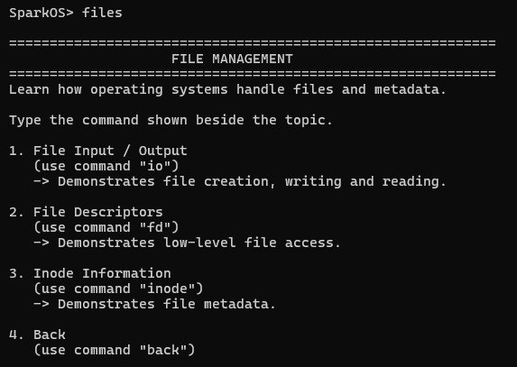demonstration shows file creation, writing and reading.

2.7.2 File Descriptors
A file descriptor is an integer used by a process to refer to an open file or I/O resource.
The demonstration shows a file being opened, accessed and closed.
Command:
fd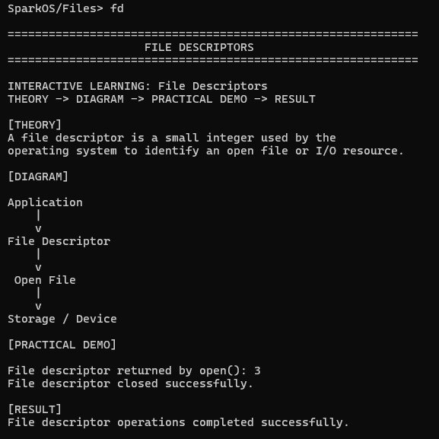

2.7.3 Inode Concept
An inode stores metadata associated with a file.
The demonstration explains concepts such as:
- File type
- Permissions
- File size
- Ownership information
- Timestamps
- Data block references
Command:
inode
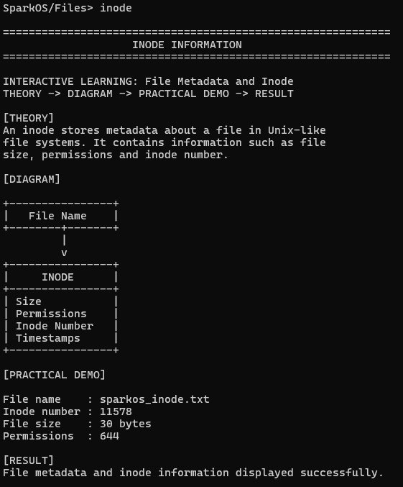

2.8 Threads and Synchronization Module
The Threads and Synchronization module demonstrates basic concurrency and synchronization concepts.
The module includes:
- Threads
- Mutex
- Semaphore

2.8.1 Threads
Multiple threads can execute within the same process.
The simplified representation is:
PROCESS
/ \
/ \
THREAD 1 THREAD 2
Command:
threads
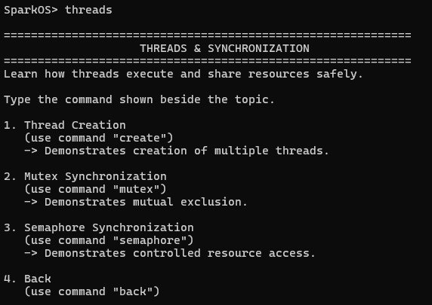

2.8.2 Mutex
A mutex provides mutual exclusion for a critical section.
The concept can be represented as:
THREAD 1 ----\
\
> MUTEX → SHARED RESOURCE
/
THREAD 2 ----/
The mutex ensures that access to the protected critical section is controlled.
Command:
mutex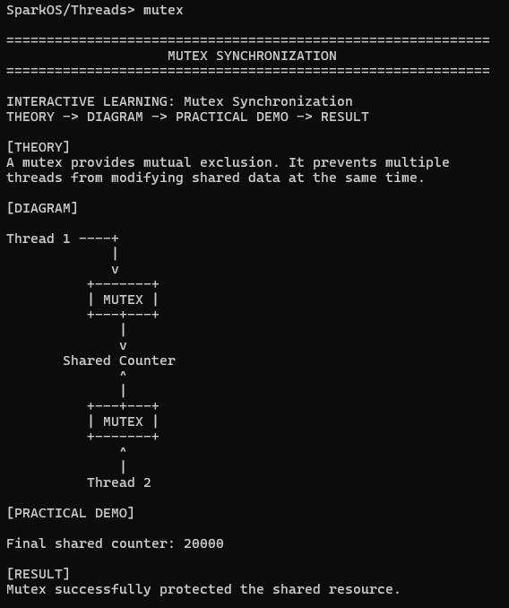

2.8.3 Semaphore
A semaphore is used to control access to a shared resource.
The demonstration shows threads entering and leaving a controlled section.
THREAD
|
v
SEMAPHORE
|
v
CONTROLLED SECTION
|
v
RESOURCE
Command:
semaphore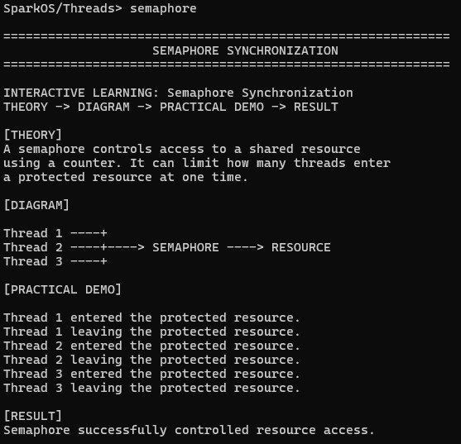

2.9 System Call Module
System calls provide a mechanism through which a user program requests services from the operating system.
Spark OS represents the concept using:
USER SPACE
|
| System Call Request
v
SYSTEM CALL INTERFACE
|
v
KERNEL SPACE
|
| Kernel Service
v
RESULT
|
v
USER SPACE
Examples of system calls include:
- read()
- write()
- open()
- close()
- fork()
Command:
syscall
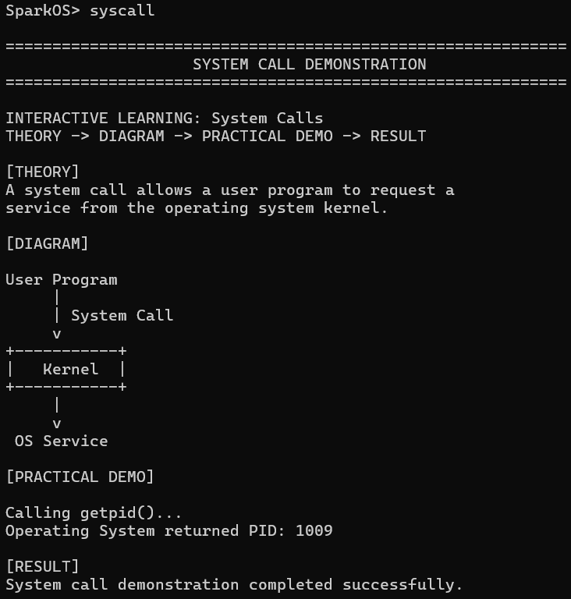
The system-call module is primarily an educational demonstration of the interaction between a user program and OS services.

3. EXPERIMENTS
The experiments in Spark OS are designed around the project's interactive learning methodology.
Each experiment follows:
THEORY
↓
DIAGRAM
↓
COMMAND
↓
PRACTICAL DEMONSTRATION
↓
OBSERVATION
↓
RESULT
The purpose of the experiments is not only to execute commands but to allow students to connect the theoretical concept with an observable result.

3.1 Process Management Experiments
The Process Management experiments demonstrate process representation, state transitions, scheduling and process creation.
The commands used are:
process
table
states
schedule
create
The demonstrations allow students to observe the process table, process lifecycle, Round Robin execution order and process creation.
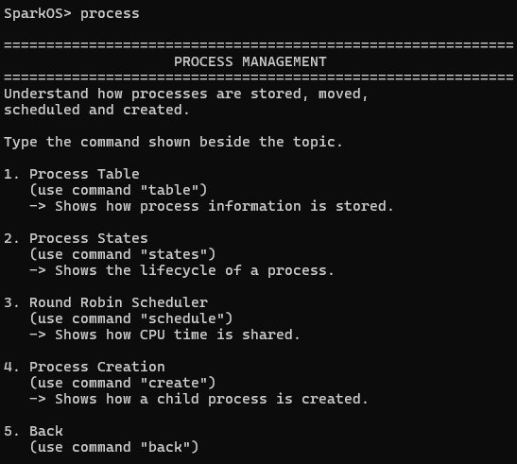

3.2 IPC Experiments
The IPC experiments demonstrate communication and asynchronous notification mechanisms.
Commands:
ipc
pipe
fifo
signal
The pipe experiment demonstrates message transfer between processes.
The FIFO experiment demonstrates named communication.
The signal experiment demonstrates asynchronous notification through a signal handler.
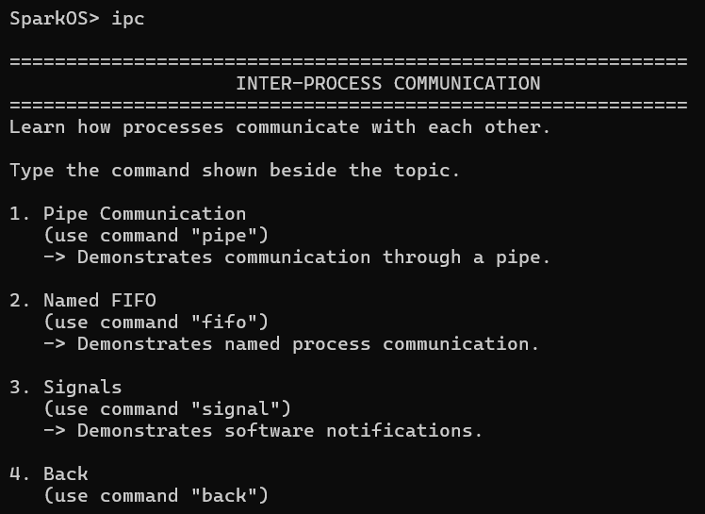

3.3 Memory Experiments
Commands:
memory
malloc
The memory experiment visualizes the process address space, while the dynamic allocation experiment demonstrates allocation and release of heap memory.

3.4 File Management Experiments
Commands:
files
fd
inode
These experiments demonstrate file creation and access, file descriptors, and the conceptual role of an inode.

3.5 Thread and Synchronization Experiments
Commands:
threads
mutex
semaphore
These demonstrations show concurrent thread execution and mechanisms used to control access to shared resources.
[

3.6 System Call Experiment
Command:
syscall
The demonstration shows the conceptual journey of a service request from user space through the system-call interface to kernel services and back to the user program.
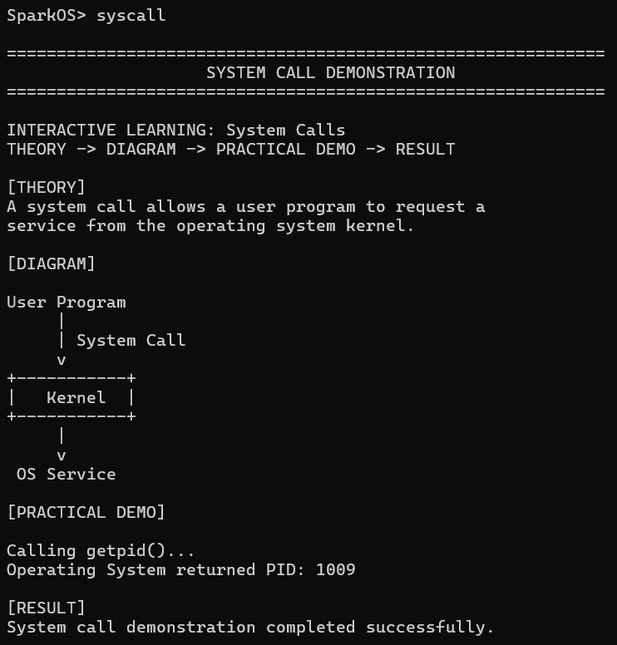

4. RESULTS

4.1 Overall System Result
The final Spark OS implementation provides a command-based educational environment for demonstrating fundamental Operating System concepts.
The user can start the program and access individual modules using commands.
The system provides modules for:
- Process Management
- Inter-Process Communication
- Memory Management
- File Management
- Threads and Synchronization
- System Calls

4.2 Process Management Result
The Process Management module successfully demonstrates process representation, process states, CPU scheduling and process creation.
The process table provides a simple representation of process information. The state demonstration visualizes the lifecycle of a process. The Round Robin demonstration shows how CPU time can be distributed among multiple processes. The process creation demonstration shows parent-child process creation using the available Ubuntu process mechanism.

4.3 IPC Result
The IPC module successfully demonstrates communication and notification concepts using pipes, FIFO and signals.
The pipe demonstration shows a message transferred between processes. The FIFO demonstration represents named communication, while the signal demonstration shows a signal handler responding to an asynchronous notification.

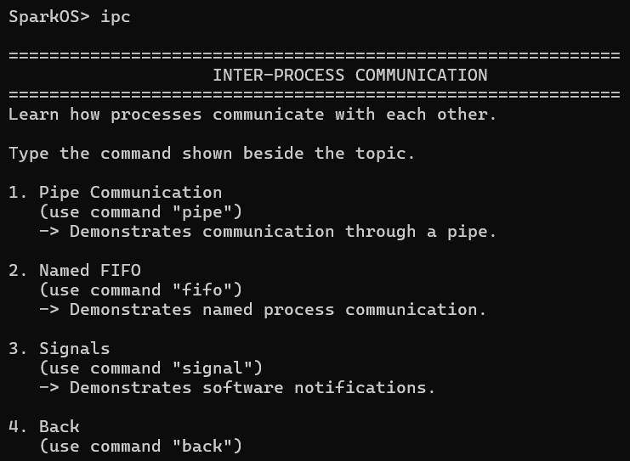4.4 Memory Management Result
The Memory Management module demonstrates the conceptual layout of a process address space and dynamic memory allocation.
The memory demonstration identifies the text, data, BSS, heap and stack regions. The dynamic allocation demonstration shows allocation of memory using malloc() and release using free().

4.5 File Management Result
The File Management module demonstrates file creation, reading, writing, file descriptors and inode concepts.
The file I/O demonstration confirms that data can be written to and read from a file. The file descriptor demonstration displays the descriptor associated with an opened file. The inode demonstration explains the metadata concept associated with a file.

4.6 Thread and Synchronization Result
The Threads and Synchronization module demonstrates thread execution and synchronization mechanisms.
The thread demonstration shows multiple threads executing. The mutex demonstration shows protected access to shared data, while the semaphore demonstration shows controlled access to a resource.

4.7 System Call Result
The System Call module successfully demonstrates the conceptual relationship between user-space programs and operating-system services.
The demonstration shows how a program requests an OS service and how the result is returned to the user program.

4.8 Integrated Final Demonstration
The final system combines the individual demonstrations into a single command-based learning environment.
The learner can move between modules using commands and access the required concept directly.
The complete learning process is:
COMMAND
↓
MODULE
↓
THEORY
↓
DIAGRAM
↓
PRACTICAL DEMONSTRATION
↓
RESULT

4.9 Summary of Implemented Modules
- Table 1. Spark OS Learning Modules
Module | Main Demonstrations
Process Management | Process Table, Process States, Round Robin, Process Creation
Inter-Process Communication | Pipe, FIFO, Signal
Memory Management | Memory Layout, Dynamic Allocation
File Management | File I/O, File Descriptor, Inode
Threads & Synchronization | Threads, Mutex, Semaphore
System Calls | System Call Flow

- Table 2. Spark OS Command Mapping
Concept | Command
Process Management | process
Process Table | table
Process States | states
Round Robin | schedule
Process Creation | create
IPC | ipc
Pipe | pipe
FIFO | fifo
Signal | signal
Memory | memory
Dynamic Allocation | malloc
Files | files
File Descriptor | fd
Inode | inode
Threads | threads
Mutex | mutex
Semaphore | semaphore
System Calls | syscall

- Table 3. Demonstration Methodology
Stage | Description
Theory | Introduces the concept in simple language
Diagram | Provides a visual representation
Command | Allows the learner to select the demonstration
Practical Demo | Executes the corresponding OS/POSIX concept
Result | Displays an observable output

5. CONCLUSION AND FUTURE WORK

5.1 Conclusion
Spark OS was developed as an educational mini-operating-system and interactive learning environment for understanding fundamental Operating System concepts.
The project addresses the difficulty students may experience when learning OS concepts only through theoretical explanations. The system provides an interactive approach in which a learner can understand a concept, visualize it using a diagram, execute a practical demonstration, and observe the resulting behavior.
The final implementation provides a command-based interface through which learners can access modules related to Process Management, Inter-Process Communication, Memory Management, File Management, Threads and Synchronization, and System Calls.
The Process Management module demonstrates process tables, process states, Round Robin scheduling and process creation. The IPC module demonstrates pipes, FIFO and signals. The Memory module demonstrates process memory layout and dynamic memory allocation. The File module demonstrates file I/O, file descriptors and inode concepts. The Threads and Synchronization module demonstrates threads, mutexes and semaphores. The System Call module provides a conceptual demonstration of the interaction between user-space programs and operating-system services.
The main contribution of the project is the integration of these concepts into a single command-based educational environment following the methodology:
Theory → Diagram → Practical Demonstration → Result
This methodology allows students to move beyond memorizing definitions and instead observe the relationship between theoretical concepts and practical execution.
Spark OS therefore provides a beginner-friendly, modular and extendable foundation for practical learning of Operating System concepts.

5.2 Advantages
The major advantages of Spark OS are:
1. Beginner-Friendly
The concepts are presented using short explanations and simple commands.
2. Interactive
Students actively interact with the system instead of only reading theoretical material.
3. Command-Based
Students can directly execute commands corresponding to the concept they want to explore.
4. Visual Learning
Diagrams help students visualize abstract Operating System concepts.
5. Practical Demonstration
Students can observe the actual output associated with the selected concept.
6. Modular
Different Operating System topics are organized into independent modules.
7. Extendable
Additional concepts and demonstrations can be added to the existing framework.

5.3 Limitations
The current system is primarily an educational demonstration environment.
The demonstrations focus on helping students understand fundamental concepts rather than implementing a complete production-level operating system.
Some demonstrations represent concepts through practical Linux/POSIX facilities available in Ubuntu, while other parts represent the concepts through educational simulations and visualizations.
Therefore, the project should be understood as an educational OS concepts learning environment, rather than a complete replacement for a general-purpose operating system.
This distinction is important because it accurately represents what the project currently achieves.

5.4 Future Scope
The project can be extended in several directions.
Advanced Scheduling
Additional CPU scheduling techniques such as FCFS, SJF, Priority Scheduling and other scheduling demonstrations can be added.
Extended Memory Simulations
Future versions can include page tables, address translation, page faults, demand paging and page replacement demonstrations.
Additional File-System Concepts
More filesystem concepts such as directory structures, inode relationships, file permissions and additional filesystem operations can be demonstrated.
Additional IPC Mechanisms
The IPC module can be extended with additional communication and synchronization mechanisms.
Advanced Synchronization
Future versions can demonstrate race conditions, deadlocks, condition variables and additional synchronization scenarios.
Improved Learning Interface
The command-based interface can be extended into a richer graphical or web-based educational interface containing interactive diagrams and animations.
Progress Tracking
Future versions could provide learning progress indicators, quizzes, exercises and concept-based assessments.
More Interactive Visualizations
The diagrams can be extended into animations showing process movement, scheduling queues, memory allocation and synchronization events in real time.
These future extensions would allow Spark OS to develop from a command-based demonstration environment into a more comprehensive Operating System learning platform.
The future extensions are consistent with the project's stated direction of adding more scheduling techniques, extended memory simulations, additional filesystem concepts, more IPC mechanisms and a more advanced learning interface. SPARK-OS (1)

6. REFERENCES
Use the following as the initial reference list only if these are among the sources you actually used/studied for the project:
[1] A. Silberschatz, P. B. Galvin, and G. Gagne, Operating System Concepts, Wiley.
[2] A. S. Tanenbaum and H. Bos, Modern Operating Systems, Pearson.
[3] W. Stallings, Operating Systems: Internals and Design Principles, Pearson.
[4] The Open Group, The Open Group Base Specifications / POSIX.1, IEEE Std 1003.1.
[5] Linux man-pages project, Linux Programmer's Manual, Linux documentation.
[6] GNU Project, GNU C Library Documentation, GNU Project.
[7] QEMU Project, QEMU Documentation, QEMU Project.
[8] GNU GRUB Project, GNU GRUB Documentation, GNU Project.

